FIGHT CARD
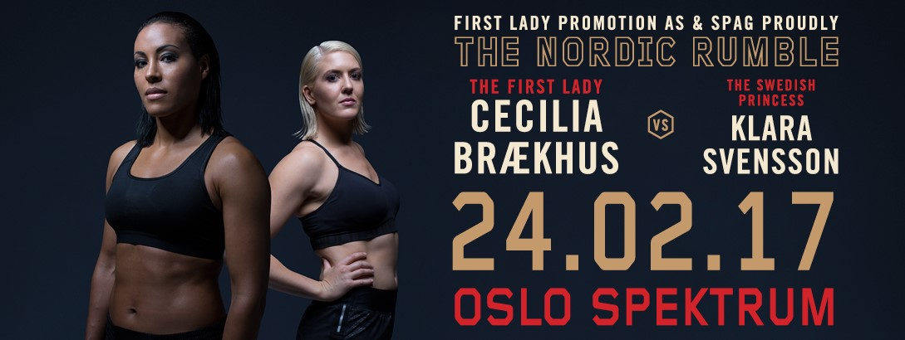
 | Red Corner |  | Blue Corner
1.  18:35 | Anebelle Bruun  Norway | 52 kg  3 rounds | Emilie Svensson  Sweden
2.  18:55 | Patricia Martinsen  Norway | 60 kg  3 rounds | Elise Saulescu  Sweden
3.  19:15 | Bernard Angelo Torres  Norway | 60 kg  3 rounds | Emil Harrysson  Sweden
4.  19:35 | Aleksander Marthinsen  Norway | 81 kg  3 rounds | Alex Bwambale  Sweden
5.  19:55 | Hadi Srour  Norway | 64 kg  3 rounds | Shukrat Abdrim  Sweden

Competition Manager |  | Box point operator
Erik Nilsen |  | Odd Inge Misund
Referee/ Judge | Geir Dahlen
Referee/ Judge | Klaus Bareksten
Referee/ Judge | Sigmund Aagaard
Referee/ Judge | Connie Aas
Referee/ Judge | Christer Palmén
Referee/ Judge | Steinar Småland
Ringside Physician | David Mcdonagh
Timekeeper | Birger Olsen
Timekeeper | Tom Vangen
Org Secretary | Oddvar Ervik

 | Blue Corner |  | Red Corner
6.  20:30 | Alexsander Hagen  1988-11-05  Oslo, Norway  11 (9-2-0) | Light Heavyweight  79,378 kg  8 rounds | Benjamin Transfeld  1985-03-23  Cologne, Germany  7 (4-3-0)
7.  21:10 | Tim Robin Lihaug  1992-09-17  Bergen, Norway  18 (16-2-0) | Light Heavyweight  79,378 kg  8 rounds | Tomas Adamek  1980-06-24  Prague, Czech Republik  41 (25-14-2)
8.  21:50 | Kai Robin Havnaa  1989-01-20  Grimstad, Norway  8 (8-0-0) | Cruiserweight  90,718 kg  8 rounds | Lars Buchholz  1981-07-07  Berlin, Germany  37 (27-10-0)
9.  23:00 | Cecilia Brækhus  1981-09-28  Bergen, Norway  29 (29-0-0) | WBC/WBA/IBF/IBO  World Title  Welterweight  66,678 kg  10x2 rounds | Klara Svensson  1987-10-15  Malmø, Sweden  18 (17-1-0)

 | BDB | WBO/WBA/WBC/IBF/IBO
Supervisor | Beate Poeske | Malte Müller-Michaelis (WBC)  Marion Palatin (WBO)  Thomas Puetz (WBA)  Edward Cotton (IBF)  Andrè van Gootenbruel (IBO)
Referee/ Judge | Oliver Brien | Massimo Barrovecchio
Referee/ Judge | Timo Habighorst | Fabian Guggenheim
Referee/ Judge | Renè Fiebig | Predrag Aleksic
Referee/ Judge |  | Robin Dolpierre
Ringside Physician in charge | David McDonagh
Ringside Physician | J.P. Grabner
Ringside Physician | Arild Østhus
Ringside Physician | Ole Rosander
Timekeeper | Martin Jahnke

